Maine Campus Compact’s (MCC) Corporate Partner of the Year Award recognizes an outstanding corporate partner for their contributions and commitment to strengthening campuses and communities in Maine. Through robust partnerships with Maine Campus Compact member institutions, the corporate partner nominee should exhibit expertise and resources in support of community-engaged learning that helps to educate and empower students in real-world problem solving. The corporate partner may: innovatively train and host your students as interns, better prepare students to be responsible and contributing members in the workforce, provide resources to help implement your community service projects, and/or provide support for community-based research. The corporate partner helps amplify the sustainability and effectiveness of community-based programs that deepen students’ knowledge of and passion for their local communities. Through this reciprocal partnership, the corporation helps students become well-informed, engaged and productive members of society, who are fully prepared to provide leadership and service that advances the public good in their communities.
Goals
- Celebrate a corporation’s public-spirited contribution(s) for strengthening Maine campuses and communities.
- Recognize innovative and sustainable partnerships between campuses, communities, and corporations that enrich student learning/engagement and enhance community life.
Qualifications
- Corporate nominee must currently partner with an MCC member institution.
Nomination Guidelines
- A campus may nominate one corporate partner.
- A completed nomination essay form must be submitted (no more than 2 pages) and include the following:
- A description of the campus/corporate partnership;
- How the corporate partner has enriched student learning;
- How the corporate partner has amplified the impact to the campus and community;
- How the corporate partner has exceeded expectations; and
  - A description of the corporate partner’s innovative approach to building or enhancing campus-based efforts to address community isssues.
- The nomination must include a letter of recommendation detailing the corporate partner’s work from one of the following:
  - President
  - Community Service/Service Learning Director
  - Faculty
- Include the corporate partner’s up-to-date contact information.
Submission
Please submit nominations to:

Maine Campus Compact
Attn: Tom Gallant
220 College Street, #2
Lewiston, ME 04240

Phone: 207-786-8392
Fax: 207-786-6053
Email: tom@mainecompact.org

Timeline
February 6, 2017: Nomination form and letter of recommendation submission deadline
March 28, 2017: Announcement of award recipients
April 26, 2017: Award recipients honored at Maine Campus Compact’s 16th Annual Awards Ceremony at Southern Maine Community College, 2:00-4:00 p.m.
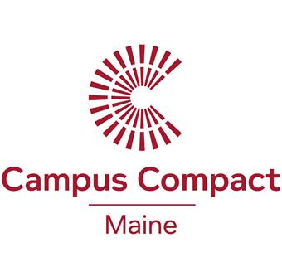
Nomination Form
Corporate Partner of the Year Award
Corporation:
Contact Name:
Address:
Phone:
Email:

Nomination Essay: (Should be 2 pages in length.)

- A description of the campus/corporate partnership;
- How the corporate partner has enriched student learning;
- How the corporate partner has amplified the impact to the campus and community;
- How the corporate partner has exceeded expectations; and
  - A description of the corporate partner’s innovative approach to building or enhancing campus-based efforts to address community isssues .

___________________________________________________________ ________________________________
Signature of Civic Engagement Representative Date
____________________________________ ____________________
Signature of President Date

Tom Gallant
Maine Campus Compact Phone: 207-786-8392
220 College St, #2 Fax: 207-786-6053
Lewiston, ME 04240 Email: tom@mainecompact.org

Due by February 6, 2017.

